SMUBI

*Saint Mary’s University Breaking the Ice*

*Team No: - 8*

Talwinder Saini-A00430396 (Talwinder.saini@smu.ca )

Jiye Wang-A00426401 (Jiye.Wang@smu.ca )

Aditya Tandon-A00432835 (Aditya.Tandon@smu.ca)

Manoj-A00432854 (Manoj.morishetty@smu.ca )

Devvrat Deshwal-A00431503 (Devvrat.Deshwal@smu.ca)

**Table of Contents**

Previous Design ………….……………………………………………………………………….. 3-4

Heuristic Evaluation ………………………….. …..………………………………………….. 5

Cognitive Walk-Through ……….…………………………………………………………….. 6-7

Modified Design Sketches **…………….….**.........…………………………………………. 8-11

Attached List …..…..………….……………………………………………………..…………….. 11

# **Previous Design**

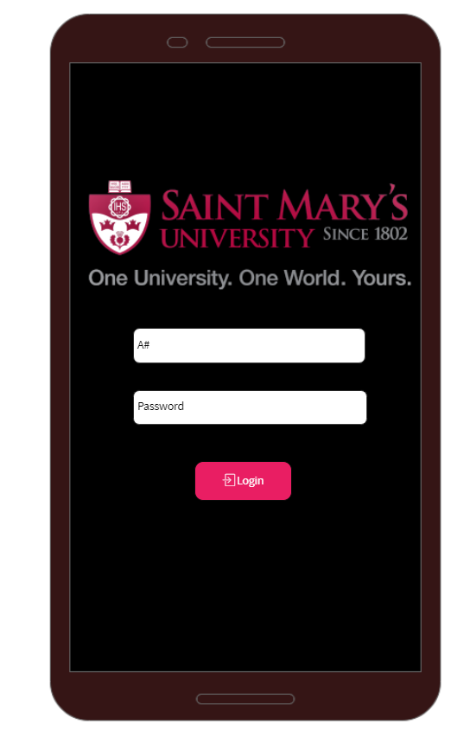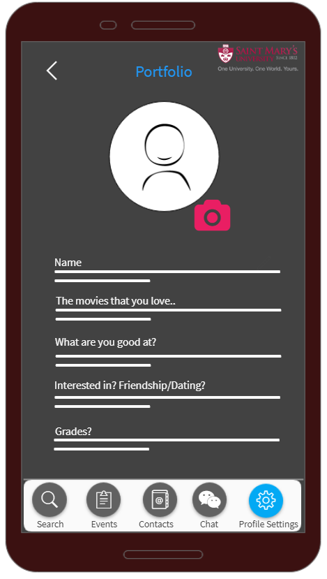

P1/P2

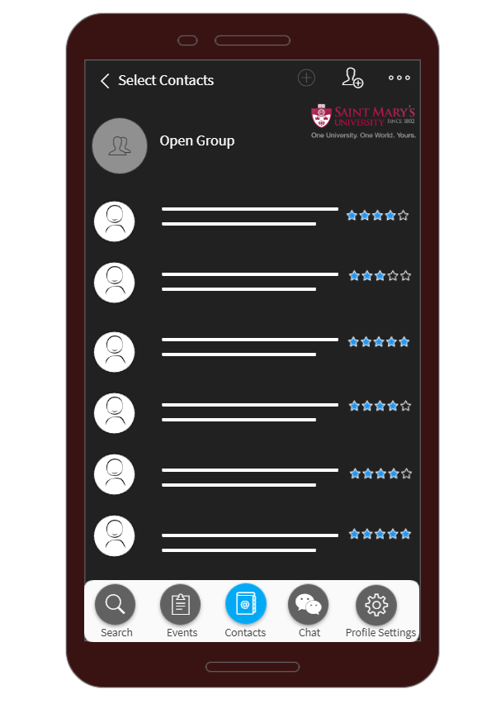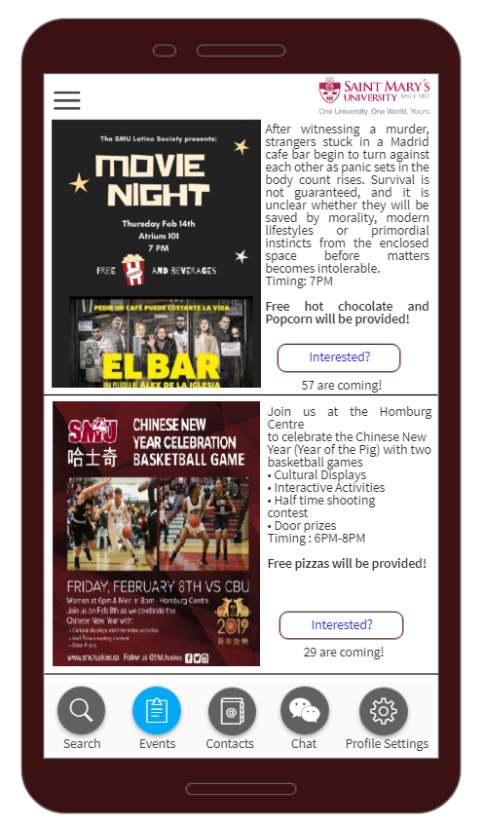

P3/P4

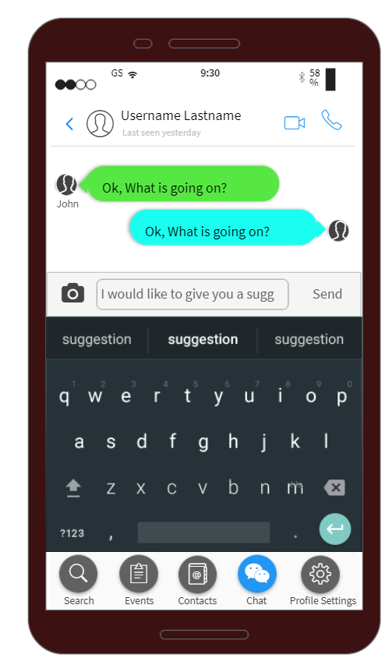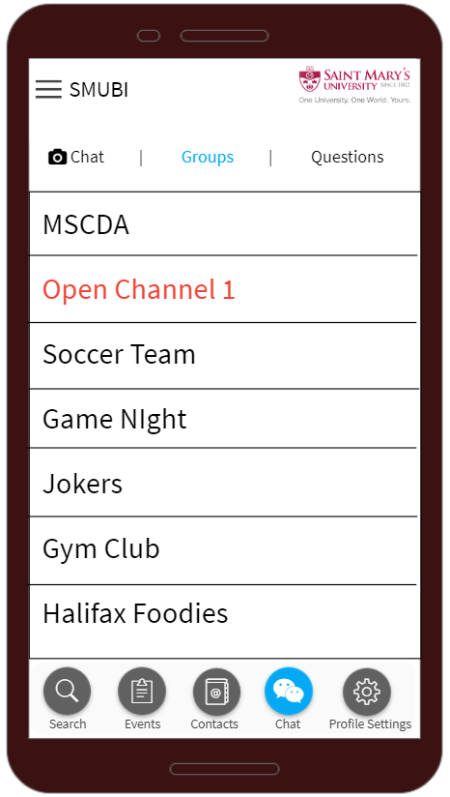

P5/P6

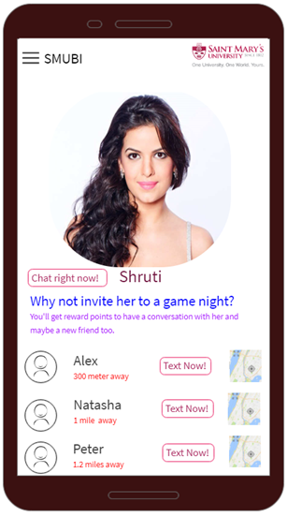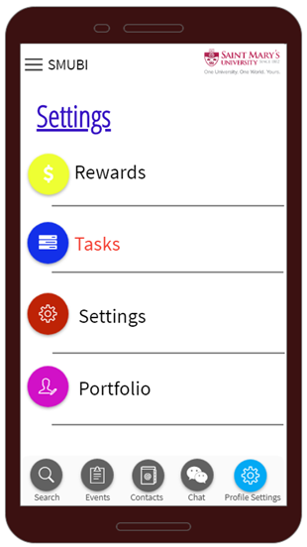

P7/P8

# **Heuristic Evaluation**

# **Cognitive Walk-Through**

**Tasks**

* Creating a portfolio for the first time
* Joining the open chat groups and starting to talk with new people (matching with the profile)
* Selecting Events which you want to join according to interests and hobbies?
* Searching for new contacts.
* Verify that user is able to edit all the profile settings.

**Task 1: Creating a portfolio for the first time**

**Step 1.** Users don’t have to register for the application. When they first open the application, they can directly sign in using their A number and password in banner.

**Step 2.** After signing up, the portfolio page will pop up and the user can edit the personal information for the first time. Some parts including photo and name are required at this time. Once the user fills the required parts, they can click the save button. This step will cost about 1 minute.

**Step 3.** By clicking the save button, there will be an animation that the last page will collapse into setting page and indicate where to edit it again. Now user able to see ‘Search’, ‘Events’, ‘Contacts’, ‘Chat’ tabs.

**Flaws in Task 1**

1. For an existing user (who already created portfolio) should navigate to settings screen.
2. There is no forgot password functionality.
3. There is no reset password functionality.
4. After filling the portfolio details there is no ‘Save’ or ‘Submit’ button.

**Task 2: Joining the open chat groups and starting to talk with new people (matching with the profile)**

**Step 1.** Now navigate to chats tab.

**Step 2.** Click search area where user able to search for groups or there is options screen where user able to search people with basis on interest or distance between them.

**Step 3**. After selecting the person, chat screen will be displayed where user able to chat and look old conversion.

**Flaws in Task 2**

1. There is no options screen where user able to search people based on interests & distance between them.

**Task 3: Selecting Events which you want to join according to interests and hobbies?**

**Step 1.** Navigate to Events tab.

**Step2.** Application algorithm automatically provide some events suggestions according to your likes and dislikes.

**Step 3.** After displaying of all the events, user can select event and get all the required information of that event.

**Step 4.** User can select any event by clicking ‘Interested’ button and suggest friends to invite for event to join his/her company.

**Flaws in Task 3**

1. There is no filter option where user can able to filter the events.
2. For better user experience ‘Interested’ button can be changed to ‘Register’ or ‘join’.

**Task 4: Searching for a person**

**Step 1.** Navigate to ‘Search’ tab.

**Step 2.** Click on search text area, where user able to search a person by ‘Individual Name’, by ‘Group Name or Community Name’, by ‘Interest’.

**Flaws in Task 4**

1. Remove the search button and add it in the contacts section.

**Task 5: Verify that user is able to edit all the profile settings.**

**Step 1:** Verify user able to change all the general settings and submit

**Step 2:** Verify user able to change privacy settings display of portfolio at different levels (Public or group level).

**Step 3:** Verify user able to exit from groups.

**Flaws in Task 5**

1. Need to implement the screen according to above steps.

**Conclusion**

There are very few blockers and few functional implementations in entire application. There needs to implement forgot password and reset password screens. Needs to changes the screens for new user and existing user. After user fills the portfolio form there is no submit button which creates a blocker for the persistence of user details. Few user experience enhancements like user able to filter the events, replace search text area to ‘Contacts’ tab.

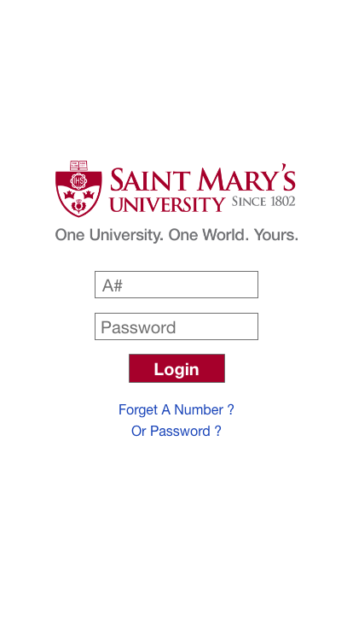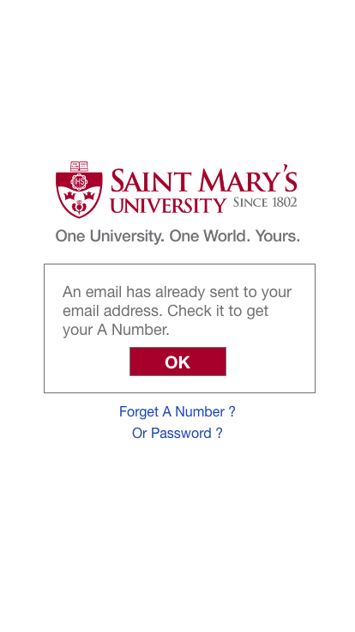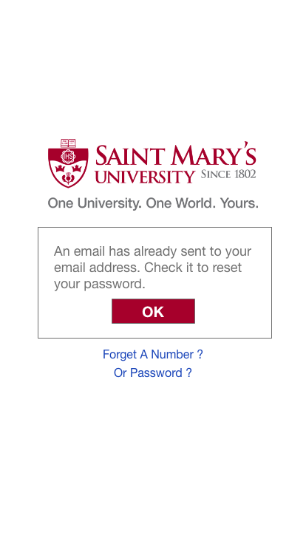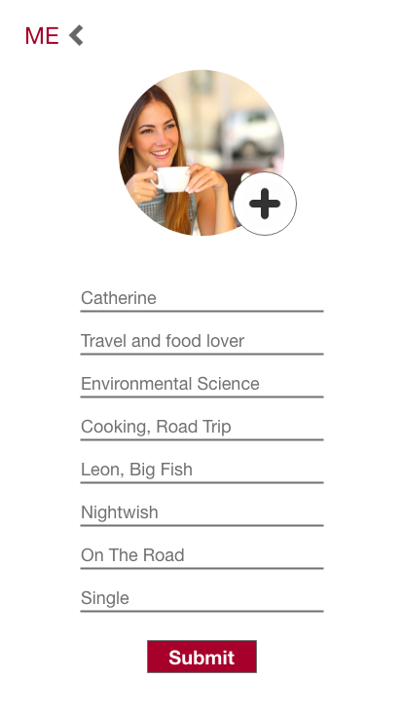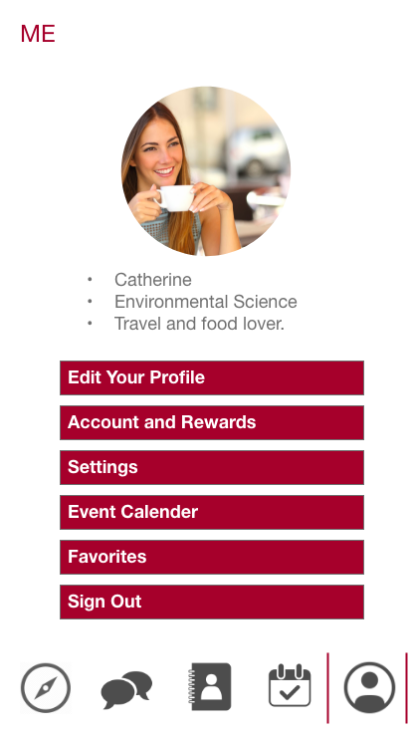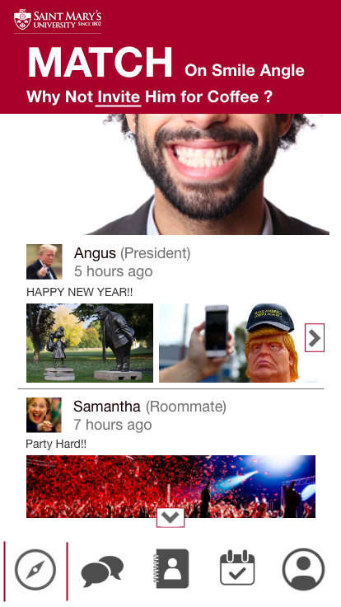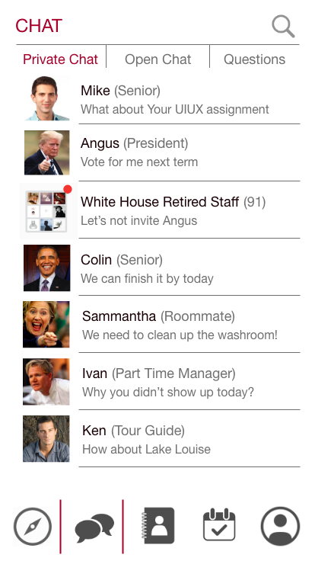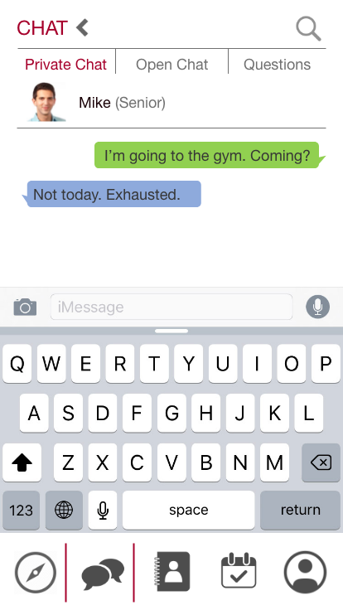 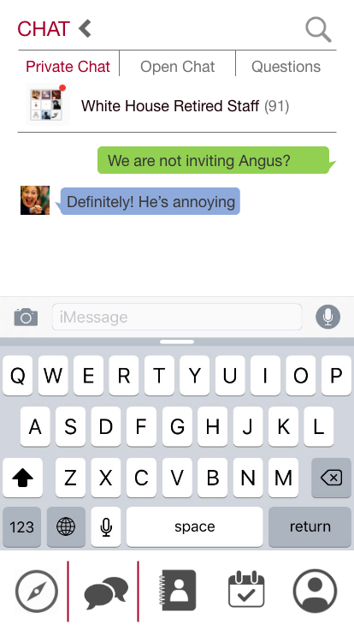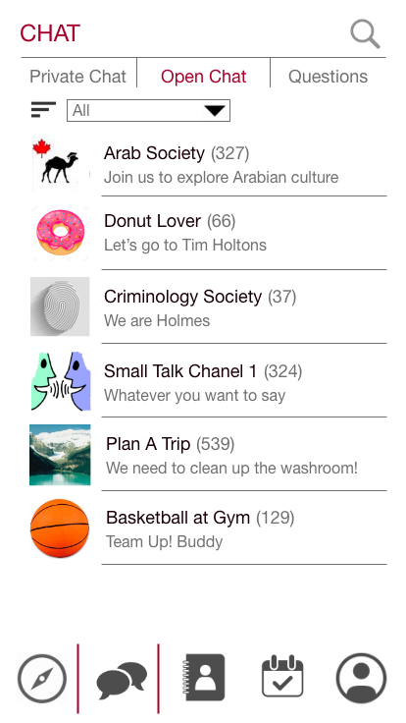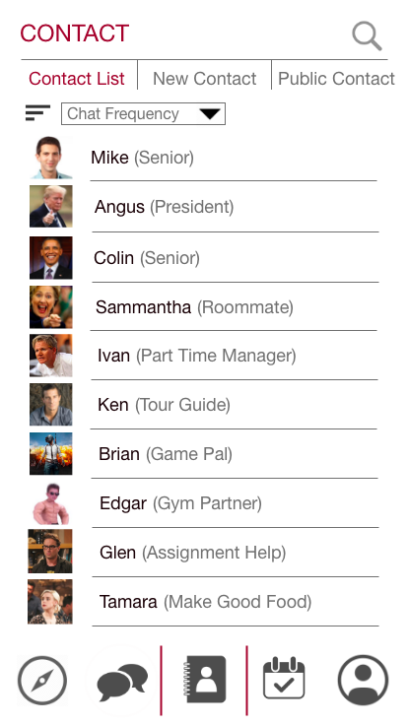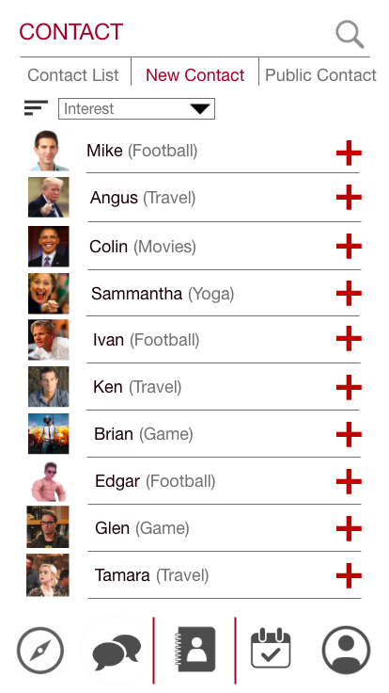

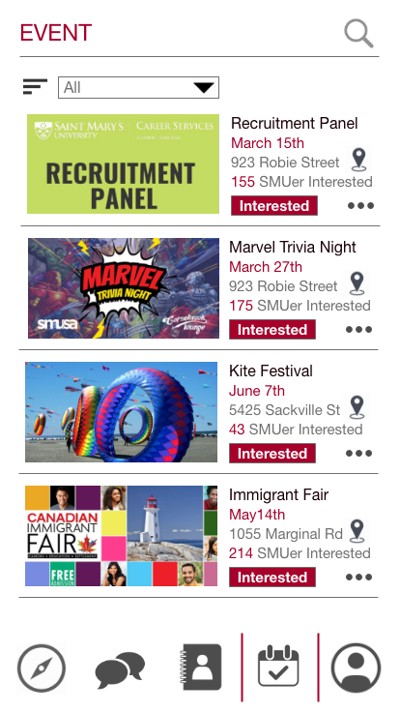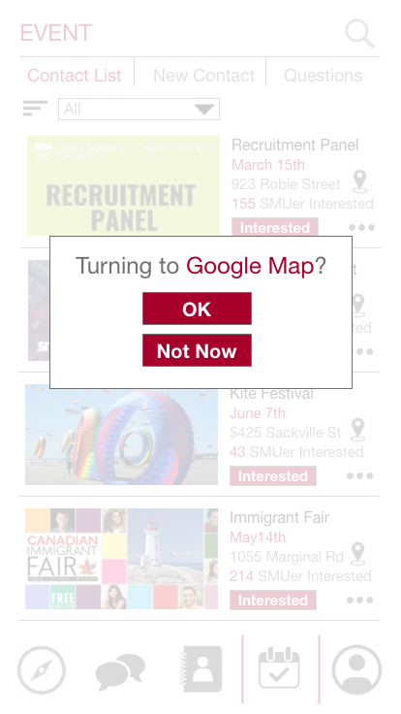

# **Attached List**

**Individual HE Forms:**

* HE_Aditya_Tandon.doc
* HE_Devvrat_Deshwal.doc
* HE_Jiye_Wang.doc
* HE_Manoj_Morishetty.doc
* HE_Talwinder_Saini.doc

**Application Mockup Video:**

* Mockup_0309.mp4